**Target Journal: Entomologia Experimentalis et Applicata**

**Title:**

**Effects of frass from larvae of black soldier fly (*Hermetia illucens*) and yellow mealworm (*Tenebrio molitor*) on growth and insect resistance in field mustard (*Brassica rapa*): differences between insect species and frass treatments**

Shaphan Y. Chia*, Joop J.A. van Loonand Marcel Dicke

Laboratory of Entomology, Wageningen University & Research, P.O. Box 16, 6700 AA Wageningen, the Netherlands.

**Short title:**

**Frass as a sustainable soil amendment, enhancing plant growth and herbivore resistance**

**\*Corresponding author:**

S.Y. Chia, e-mail: shaphan.chia@wur.nl, mobile tel.: +31620409215

**Key words:**

Insect production, Insect residual streams, Soil amendment, Organic fertiliser, Incubated frass, Composted frass, Raw frass, Sustainable agriculture, Pest management, *Delia radicum, Plutella xylostella,* Insect herbivory

**Abstract**

Frass, a byproduct of insect rearing, has become popular for its potential use in sustainable agriculture. The rapid growth of insect production results in an increased frass output. This study examined the effects of frass as soil amendment on plant growth and resistance to insect herbivory. In greenhouse experiments, *Brassica rapa* L. (Brassicales: Brassicaceae) was grown in unamended soil (NoFrass; control) or soil amended with frass (2g kg−1) from larvae of black soldier fly, *Hermetia illucens* L. (Diptera: Stratiomyidae)(BSFF) or yellow mealworm, *Tenebrio molitor* L. (Coleoptera: Tenebrionidae) (MWF). Frass was applied as raw, incubated, or composted frass before seed germination. Plant growth and performance of root-feeding *Delia radicum* L. (Diptera: Anthomyiidae), and shoot-feeding *Plutella xylostella* L. (Lepidoptera: Plutelliidae), larvae were measured. Initially, raw BSFF and MWF reduced growth of *B. rapa* and resulted in a smaller leaf area compared to NoFrass. However, over time, a notable trend emerged. While the difference in leaf area between MWF and NoFrass disappeared, BSFF consistently resulted in a smaller leaf area compared to both MWF and NoFrass. Raw BSFF reduced *D. radicum* larval survival and pupal biomass and survival of *P. xylostella* larvae. In contrast, raw MWF increased larval survival and biomass of *D. radicum* and the survival of *P. xylostella* larvae. Interestingly, incubation of frass in the soil for 16 days before seed germination removed plant growth inhibition and resulted in an increased plant leaf area, especially for MWF compared to NoFrass. In addition, composting MWF increased leaf growth. Therefore, frass may be used as a sustainable and natural alternative to conventional organic fertilisers, promoting plant growth and enhancing resistance to herbivory. Our results indicate that soil amendment with raw BSFF may negatively impact herbivore performance, whereas raw MWF may have a protective effect on herbivore performance.

**Introduction**

In recent years, alternative protein sources for animal feed and human food have received increasing interest because of the need to produce food for the growing human population in a sustainable manner. The use of insect-based feed, in particular, has become popular due to its high nutritional value and low environmental impact (van Huis, 2013). Among various insect species, larvae of the black soldier fly *Hermetia illucens* L. (Diptera: Stratiomyidae) and the yellow mealworm *Tenebrio molitor* L. (Coleoptera: Tenebrionidae) have emerged as promising candidates for animal feed and human food respectively. These insects have a high protein content, rapid growth rate, and are amenable to mass-rearing (Chia et al., 2020; Mariod, 2020; Toviho & Bársony, 2022; Zulkifli et al., 2022).

In addition to the use of insects as feed or food, insect products have been investigated for their potential as organic fertilisers. Insect frass, a mixture of insect excrements, leftover substrate, and exoskeletons left after moulting, is nutrient-rich and can enhance soil health and plant growth. For instance, the addition of frass to the soil may enrich the soil with specific beneficial soil microbes, such as plant growth-promoting rhizobacteria (PGPR). The potential of frass to increase crop yields has been demonstrated (Barragán-Fonseca et al., 2022; Dzepe et al., 2022; Houben et al., 2021; Houben et al., 2020; Lopes et al., 2022; Poveda, 2021). Frass may also confer plant resistance to insect herbivores (Barragán-Fonseca et al., 2022; Poveda, 2021). Induced systemic resistance has been linked to bacilli, which are common PGPRs in agricultural soils. PGPRs are rhizosphere bacteria that colonise the roots and increase host plant resistance to diseases and insect herbivory (Basu et al., 2021; Berendsen et al., 2012; Gadhave et al., 2016; Hu et al., 2018; Mahapatra et al., 2022; Pineda et al., 2010). Bacilli are well-known to induce plant resistance to insect infestation (Gadhave et al., 2016; Pangesti et al., 2013). Plants and beneficial soil microorganisms can use frass as a nutrient and energy source when added to the soil. Inorganic nitrogen (N) is released from soil amendments through microbial decomposition. Chitinolytic microbes can control insect pests biologically (Sharp, 2013). Thus, amending soil with chitin-rich residual streams may promote beneficial antagonists.

As the edible insect industry grows, so will the amount of frass produced (Chia et al., 2019; Houben et al., 2020; Poveda, 2021; Salomone et al., 2017). Following the rapid growth of the edible insect industry and the potential of frass as a viable fertiliser and its contribution to a circular economy, the European Commission has enacted legislation (Regulation (EU) 2021/1925) to regulate its production and use. Analyses of frass produced by BSF larvae (BSFF) fed various food leftovers indicate that it ranges in total N content from 0.6 to 4.8 %, in total phosphorus (P) content from 0.1 to 2.5 %, and in potassium (K) content from 0.1 to 2.1%, as well as providing trace minerals and beneficial microorganisms (Basri et al., 2022; Choi & Hassanzadeh, 2019; Poveda, 2021). Mealworm frass (MWF), on the other hand, ranges in total N content from 2.7 to 7.8%, total P from 1.0 to 1.5% and total K from 1.2 to 2.0%. It also contains calcium, magnesium, and micronutrients (Poveda et al., 2019). Moreover, BSFF and MWF contain chitin, which can enhance the abundance of soil microbiota and generate antimicrobial peptides that serve as a plant's defence barrier (Choi & Hassanzadeh, 2019; Nurfikari & de Boer, 2021; Poveda et al., 2019; Schmitt & de Vries, 2020). High concentrations of P in BSFF promote N accumulation in plants (Klammsteiner et al., 2020). This makes it an excellent source of nutrients for plants, as it can improve soil fertility, enhance plant growth and increase crop yields. By reintroducing and valorizing relevant nutrients and organic matter into the soil, the use of frass can help to close the nutrient cycle in insect farming. This strategy contributes to the development of a zero-waste food production system and highlights the significance of identifying sustainable sources of organic matter for soil amendment and food production.

Field mustard (*Brassica rapa* L.) is a member of the Brassicaceae family and is widely cultivated for food, oil, and feed, and it has a high economic value due to its nutritional, medicinal, and bio-industrial properties (Young-Mathews, 2012). However, it is also a preferred host for various insect herbivores, including the root-feeding larvae of the cabbage root fly *Delia radicum* and the shoot-feeding larvae of the diamondback moth *Plutella xylostella* (Ahuja et al., 2010), which can cause substantial economic losses (Ahuja et al., 2010). To mitigate plant damage caused by insect herbivores, various methods have been employed, including the use of chemical pesticides. However, the overuse of pesticides has led to numerous environmental and health concerns (Nicolopoulou-Stamati et al., 2016), Therefore, effective, sustainable, and safe alternatives for managing insect herbivores are required.

To date, there is limited research on the potential of frass to enhance plant development and resistance to insect herbivory. A recent study showed that mealworm exuviae did not affect shoot and root dry biomass of *B. oleracea* (Wantulla et al., 2022). The study further recorded a reduced survival of *D. radicum* larvae in BSFF-exposed soil, but mealworm exuviae did not affect larval survival and biomass compared to a synthetic fertiliser. However, Wantulla et al. (2022) did not investigate the effects of MWF, which is the most abundant byproduct of mealworm cultivation. Furthermore, evaluations of plant growth in frass-amended soil and herbivore performance on such plants have largely been limited to a few plant species and insect herbivores under soil treatment with frass, thus limiting the generalisation of the results. To address this knowledge gap, it is crucial to examine the impact of various types of frass and to consider other plant species and their resistance to biotic stress, such as insect herbivory. It is also important to extend investigations to multiple herbivores. Intriguingly, the question of whether insect frass can replace traditional organic and mineral fertilisers as well as chemical insecticides in agricultural systems still requires further research. There is currently no single paper that addressed this question and several studies on soil fertility have mainly focused on frass application to improve soil health and promote plant growth, with limited attention to its potential effect on insect herbivore performance (Poveda, 2021; Wantulla et al., 2022). Exploring the effects of insect frass on plant resistance to herbivores, can provide insights into its use as a pest management strategy and reduce the need for chemical pesticides.

Here, we aimed to investigate the effects of frass derived from BSF and yellow mealworm larvae on growth performance of *B. rapa* and resistance of the plants to the herbivores *D. radicum* and *P. xylostella*. We hypothesised that frass, due to its high nutrient content, would enhance the growth of *B. rapa* and confer resistance to the herbivores, compared to control plants that received no frass. Additionally, we hypothesised that incubating frass in the soil or composting it will enhance its effectiveness as a soil amendment and lead to greater plant growth than non-incubated or uncomposted frass. In fact, composting is a common method of preparing organic materials for use as soil amendments (Barthod et al., 2018; Goldan et al., 2023). The findings of this study contribute to our understanding of the potential benefits of using frass as a sustainable and environmentally friendly fertiliser in agriculture.

**Materials and Methods**

**Experimental facility and greenhouse soil**

We conducted greenhouse experiments to assess how frass resulting from the production of two edible insect species affected the growth of field mustard, *Brassica rapa* L. (Brassicales: Brassicaceae) plantsand the survival of a belowground and an aboveground insect herbivore. The study was conducted in the greenhouse facilities at Unifarm, Wageningen University & Research, the Netherlands. The soil used in this study was collected at Unifarm’s organic experimental farm Droevendaal. Various brassicaceous plant species had been grown on this soil since 2011 and black mustard, *Brassica nigra* L. (Brassicales: Brassicaceae) had recently been grown at the location selected for soil collection.

**Raw material and soil amendments**

The frass used in this study was obtained from two commercially reared edible insect species: (1) black soldier fly larvae *Hermetia illucens* L. (Diptera: Stratiomyidae) provided by Bestico, Berkel en Rodenrijs, the Netherlands and (2) yellow mealworm larvae, *Tenebrio molitor* L. (Coleoptera: Tenebrionidae), provided by Nijenkamp-Voederdieren, Oldenzaal, the Netherlands. Before use, frass samples were oven-dried at 60 °C for 24 h (Binder Model FED-260, Binder GmbH, Tuttlingen, Germany), pulverised using a cutting mill SM 100 (Retsch B.V., Haan, Germany), sieved (2-mm mesh size), and then stored in air-tight containers at room temperature for 78 days. We refer to the pulverised frass as *“raw frass”* to differentiate it from other forms of frass used in this study i.e., *“incubated frass”* and *“composted frass”* (see details in sections below). The soil was amended with the pulverised frass by adding 2 g of frass per kg of soil that had previously been sieved (5 mm) to remove large debris. To mix frass and soil, 20 g of frass was added to 10 kg of soil in plastic bags and mixed thoroughly by hand until there were no visible frass clumps. Soil amended with frass of the black soldier fly larvae was labelled as “BSFF” while soil amended with frass of yellow mealworms was labelled as “MWF”. The same procedure was followed for the control (NoFrass), except that no frass was added. In two trials (Trial 1 and Trial 2), raw frass was added to the soil. Subsequently, samples of the raw frass were either incubated in the soil (Trial 3) or composted (Trial 4) before being added to the soil for plant growth. Trial 2 is a repeat of Trial 1 under similar conditions and applying similar procedures. Trial 1 started (i.e., seed germination) on January 30, 2021; Trial 2 started on March 1, 2021; Trials 3 and 4 started on March 26, 2021.

**Insect rearing**

*Delia radicum*

The cabbage root fly, *Delia radicum* L. (Diptera: Anthomyiidae) is an important pest of brassicaceous vegetables. This insect species was reared by the insect rearing team of the Laboratory of Entomology, Wageningen University & Research. The larvae of this colony were fed on rutabaga *Brassica napus* L. (Brassicales: Brassicaceae) until pupation. Adults were kept in gauze cages and fed on a mixture of sugar, milk powder, yeast and honey. Water was provided in cotton wool. The insect colony was maintained in a climate cabinet (22 ± 1 °C, 50-70 % RH). For experiments, we obtained young larvae (< 24 h since hatching).

*Plutella xylostella*

The diamondback moth (DBM), *Plutella xylostella* L. (Lepidoptera: Plutellidae), is one of the most destructive insect herbivores of cruciferous plants worldwide (Wei et al., 2013). Neonate larvae of DBM were supplied by the insect rearing team of the Laboratory of Entomology, Wageningen University & Research, where they were fed on Brussels sprouts plants (*Brassica oleracea* variety *gemmifera* cultivar Cyrus) in greenhouse conditions (22 ± 3 °C, 50-70 % RH).

**Field mustard (*Brassica rapa*) seeds and germination**

Field mustard, *Brassica rapa* L. (Brassicales: Brassicaceae) is an annual or biennial herb (Ilyas et al., 2022). *Brassica rapa* seeds originated from a natural population in the Netherlands and were kindly provided by Erik Poelman (Laboratory of Entomology, Wageningen University & Research). Before sowing, the seeds were stratified by maintaining them on moist filter paper at 4 °C for 7 days to break seed dormancy. Seeds were germinated using unamended soil in the greenhouse (22 ± 3 °C, 60 ± 2 % RH). In this study, seeds germinated in unamended soil (NoFrass) had a high germination rate (> 90%), whereas those sown directly into the frass-amended soil had a slightly lower germination rate, but there were no significant differences among the trials (*χ2* = 2.97; df = 3; *p* = 0.3961; Table S1).

**Plant growth performance in soil amended with raw frass**

At the emergence of the first true leaf (7-day-old plants), seedlings were transplanted individually into amended and unamended soil in 1 L plastic pots placed individually in round saucers (16 cm wide, 1.8 cm deep). Plants were randomly assigned to the two soil amendments (BSFF and MWF) in 30 replicate pots placed on a table in a greenhouse compartment. During the first two weeks since germination, plants were watered twice per week, from the third week onwards three times per week, by filling the saucer until the topsoil became moist. Weeds in experimental pots were manually removed. This experiment was repeated after four weeks following the same procedure. At 21 days after seed germination, plant growth measurements included a leaf count to record the number of leaves per plant, and the width (cm) of the second most mature true leaf (leaf formed after seedling transplant) measured at the broadest point of the leaf. The same measurements were repeated at 28, 35 and 42 days since germination. Every week, the next mature true leaf was measured until the onset of plant bolting (development of flowering stems). From this point onwards, plants were monitored daily and the number of days until the first flower emerged was recorded as the time until flowering.

**Assessment of plant resistance to insect herbivory**

The resistance of raw-frass-exposed *B. rapa* plants to two insect herbivores, *D. radicum* and *P. xylostella,* was assessed by recording leaf damage, larval survival, and pupal biomass. When plants were four weeks old, ten larvae (< 24 h old) of *D. radicum* were released at about 0.5 cm into the soil close to the stem of each potted plant. Their survival was assessed when the larvae fed on roots of frass-exposed *B. rapa* plants. Ten plants per treatment and control (BSFF, MWF and NoFrass) were inoculated. After 21 days, all plants were uprooted, and roots were rinsed to remove adhering soil. The roots were then examined for larvae that remained, and all the soil was washed away using a Fenwick Can (Metaalgaas Twente, Hengelo, the Netherlands) and a sieve with a 0.5 mm aperture (Wantulla et al., 2022). All pupae and larvae retrieved per plant were recorded. Wet pupal weight was recorded using an Ohaus Adventurer Pro AV213 balance with an accuracy of 0.001 g. To assess the effect of soil amendment on pupal development, all pupae retrieved from roots of plants exposed to the soil treatments were placed in a Petri dish at 22 ± 1 °C, 50-70 % RH. The number of adult flies that emerged and the time (days) taken to emerge were recorded daily until all pupae had either emerged as flies or appeared to be dead. This experiment was repeated four weeks later, following the same procedure.

To assess the effect of raw-frass-exposed plants on the survival of *P. xylostella* larvae, ten second-instar larvae were inoculated on one fully expanded leaf of each replicate *B. rapa* plant. Inoculated plants were immediately enclosed in transparent mesh bags to contain the larvae and prevent their escape. The mesh bags were monitored daily to record the pupation of the larvae. The experiment was terminated when all larvae had either pupated or appeared to be dead. Ten replicate plants per treatment (BSFF, MWF or NoFrass) were used in this experiment. This experiment was repeated once more following the same procedure.

The extent of leaf damage by the larvae of *P. xylostella* on raw-frass-exposed *B. rapa* plants was assessed visually on a 1-to-7 scoring scale (Fig. 1). A score of 1 means no visible damage to the plant, and a score of 7 means extensive damage to the plants (Robin et al., 2017). The average values from ten plants were calculated for each soil amendment.

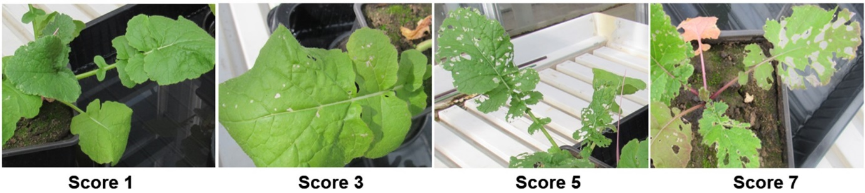

**Figure 1.** Visual representation of feeding scores used to assess the extent of leaf damage in greenhouse-grown *Brassica rapa* plants by larvae of diamondback moth (DBM) *Plutella xylostella*. The score ranged from ‘1’ to ‘7’ with ‘1’ being scored for leaves with no damage symptoms and ‘7’ being scored for heavily damaged leaves. Intermediate values on the scale represent different levels of damage (Robin et al., 2017).

**Incubation and composting of raw frass: effects on plant growth performance**

*Incubation of ‘raw frass’ in the soil*

Incubation was achieved by mixing 2 g of raw frass per kg of soil. The amended soil was placed in 0.5 L plastic pots in saucers (14 cm wide, 1.5 cm deep). The soil mixture in pots was moistened by filling the saucers with water twice a week. This incubation of frass was maintained for 16 days under greenhouse conditions. The same procedure was followed for the unamended soil (control) except that no frass was added. Stratified seeds of *B. rapa* were sown directly into the soil. Three seeds were sown in each pot and seven days after germination, seedling numbers were reduced to maintain only one seedling per pot. When plants were 14 days old, measurements of the leaf width (cm) and the number of leaves per plant were taken as described for *raw frass*. Six replicate plants per treatment were used in this study and measurements were repeated on the same plants at 21, 28 and 35 days since germination. Plants were further monitored, and the first flowering date was recorded to calculate the time from germination until flowering.

*Composting of ‘raw frass’*

Fifty grams each of black soldier fly larval frass and yellow mealworm frass were placed in plastic boxes (17.5 x 12.5 x 6.5 cm). The pulverised raw frass samples were moisturized with 100 mL of water and the frass in the containers was covered with a perforated aluminium foil to allow ventilation, but also to reduce evaporation and maintain a high temperature inside the box relative to the external environment. Frass inside the box was aerated by stirring it vigorously after every five days using a spatula. The composting lasted for 38 days. Composting of frass was terminated by removing the aluminium foil cover and allowing the compost to air-dry for 18 days. Then, the composted frass was pulverised and added to the soil at 2 g kg−1 of soil. As described above, three stratified seeds were sown in each pot and seven days after germination seedling numbers were reduced to maintain only one seedling per pot. Percent seed germination in amended and unamended soil was recorded. Twelve replicate plants per soil treatment were used in this study and the number of leaves and leaf width per plant were measured at 14, 21, 28 and 35 days since germination. Plants were further monitored and the time from germination until emergence of the first flower was recorded.

**Data processing and statistical analysis**

All analyses were performed using the R environment for statistical computing (version 4.2.2) (R Core Team, 2022). A linear regression model estimated leaf area *(area = 0.88735*(leaf width)2+0.93503*leaf width)* from linear measurements (leaf width) (Tartaglia et al., 2016). The normality of data was verified by visualisation using boxplots and QQ plots as well as subjected to the Shapiro-Wilk test. Homogeneity of variance was checked using Levene’s test. Data on leaf area and the number of leaves were analysed with a generalised linear model (GLM) using the *‘glm* function. For each trial, soil amendment (treatment) was included in the model as a predictor variable. Larval survival data were analysed with a Poisson-based model. Pupal biomass and leaf damage score data were analysed with a generalised linear model (GLM) using the *‘glm* function. To determine the effect of soil amendments on the proportion eclosion of *D. radicum,* dataon the proportion of adult flies that emerged were analysed with a Chi-square test of equality of proportions (Adedia et al., 2020). For fly emergence time of *D. radicum*, and time until flowering of *B. rapa* plants, data were analysed with the Poisson regression model using the *‘glm’* function, estimated by the maximum likelihood to capture the relationship between the number of days taken for flies to emerge from pupae, and for the first flower to emerge (Zeileis et al., 2008). The ‘*Anova’* function of the ‘*car’* package was used to generate the model output for the main effects with Chi-square (*χ2*) values, degrees of freedom (df) and *p*-values using the Wald Chi-square test (Fox et al., 2012). Akaike’s Information Criterion (AIC) was used to estimate the degree of fit of statistical models with the lowest AIC values considered as best in estimating the model prediction error. The mean effects of treatment were considered significant at *p* < 0.05. The *‘emmeans’* function was used to perform pairwise comparisons among soil treatments with *p*-values adjusted according to the Tukey method for comparing estimates when a significant effect of soil treatment was detected in the larval survival and pupal weight (Lenth & Lenth, 2018). In the leaf area and number of leaves, the '*glht*' function was used to perform pairwise comparisons with *p*-values adjusted according to the '*holm*' method for multiple comparisons adjustment. After conducting a Generalized Linear Model (GLM) to evaluate the differences among treatment groups for time until flowering and leaf area in composted frass treatments, post hoc comparisons were performed using the Fisher’s Least Significant Difference (LSD) post hoc test. The GLM analysis revealed significant differences among the treatment groups. However, when applying the Tukey post hoc test for multiple comparisons, no significant differences were detected. Considering this, the LSD post hoc test was chosen as an alternative method to investigate pairwise differences between treatments, as it does not assume equal variances and does not require homogeneous sample sizes. The LSD test allows for direct pairwise comparisons, and it was used to identify any significant differences that may have been missed by the Tukey test. Following a significant Chi-square test of equality of proportions, the Marascuilo procedure for multiple comparisons was used to determine significance of differences (Wagh & Razvi, 2016).

**Results**

**Effects of raw frass on the growth and development of *B. rapa* plants**

Amending soil with either raw BSFF or raw MWF affected the growth of *B. rapa* plants. Initially, both frass types, BSF frass (BSFF) and yellow mealworm frass (MWF) resulted in a significantly smaller leaf area than the control (NoFrass) (21 days: *χ2* = 14.26, df = 2, *p* = 0.0008; 28 days: *χ2* = 56.67, df = 2, *p* < 0.0001; Figure 2). However, over time, an interesting trend emerged. While the difference in leaf area between the MWF-treated group and NoFrass disappeared, BSFF consistently resulted in a smaller leaf area compared to both MWF and NoFrass (35 days: *χ2* = 73.64, df = 2, *p* < 0.0001; 42 days: *χ2* = 94.14, df = 2, *p* < 0.0001; Figure 2). When this experiment was repeated under similar conditions, BSFF consistently resulted in a smaller leaf area than both MWF and NoFrass (Figure S1).

**Figure 2**. Leaf area (cm2) of *Brassica rapa* plants grown in unamended soil (NoFrass; control) or soil amended with raw BSF frass (BSFF) or raw yellow mealworm frass (MWF) recorded in Trial 1. The box represents the interquartile range (IQR), with the bottom and top edges corresponding to the first quartile (Q1, 25%) and third quartile (Q3, 75%), respectively. The line within the box represents the median, while the whiskers extend to 1.5 times the IQR, encompassing the minimum (Q1-1.5IQR) and maximum (Q3+1.5IQR) values. The hollow dots beyond the whiskers represent outliers. The white square on each box represents the mean leaf area per plant. Data were analysed with a generalised linear model (GLM). n is the number of replicate plants for leaf area measurements. Boxes with different letters are significantly different (Tukey's post-hoc test, *p* < 0.05).

The addition of raw BSFF or raw MWF to the soil initially resulted in a significantly smaller number of leaves per *B. rapa* plant when compared to the unamended control (21 days: *χ2* = 10.40, df = 2, *p* = 0.0055; 28 days: *χ2* = 32.92, df = 2, *p* < 0.0001; Figure S2). However, over time, the difference in number of leaves between the MWF and NoFrass disappeared, while BSFF continued to exhibit a smaller number of leaves compared to both MWF and NoFrass (35 days: *χ2* = 44.62, df = 2, *p* < 0.0001; 42 days: *χ2* = 33.64, df = 2, *p* < 0.0001; Figure S2). Repeating the experiment under comparable conditions gave similar results, with no significant difference between MWF and NoFrass, and BSFF displaying a consistently smaller number of leaves (21 days: *χ2* = 17.62, df = 2, *p* = 0.0002; 28 days: *χ2* = 33.15, df = 2, *p* < 0.0001; 35 days: *χ2* = 48.37, df = 2, *p* < 0.0001; 42 days: *χ2* = 49.80, df = 2, *p* < 0.0001; Figure S3).

Amending soil with raw BSFF or raw MWF resulted in significant differences in the time until flowering of *B. rapa* plants (*χ2* = 6.25, df = 2, *p* = 0.0441; Figure S4). The application of raw BSFF resulted in a longer time until flowering than MWF and NoFrass (Figure S4A). There was no significant effect of soil treatment on time until flowering when this experiment was repeated under similar conditions (*χ2* = 1.44, df = 2, *p* = 0.4859; Figure S4B).

**Effect of raw frass on the survival of *Delia radicum* larvae**

Frass treatments affected the number of *D. radicum* larvae that survived after a 21-day root infestation of *B. rapa* (*χ2* = 31.02, df = 2, *p* < 0.0001; Figure 3). Soil amendment with BSFF resulted in the lowest median survival rate (35%) of *D. radicum* larvae, followed by MWF (60%) and NoFrass (70%). (Figure 3). Similar results were recorded when the experiment was repeated under comparable conditions (*χ2* = 56.28, df = 2, *p* < 0.0001; Figure S5).

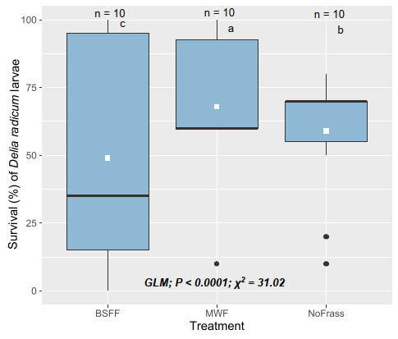

**Figure 3.** Survival of *Delia radicum* larvae on roots of *B. rapa* plants grown in unamended soil (NoFrass; control) or soil amended with raw BSF frass (BSFF) or raw yellow mealworm frass (MWF) recorded in Trial 1. The box represents the interquartile range (IQR), with the bottom and top edges corresponding to the first quartile (Q1, 25%) and third quartile (Q3, 75%), respectively. The line within the box represents the median, while the whiskers extend to 1.5 times the IQR, encompassing the minimum (Q1-1.5IQR) and maximum (Q3+1.5IQR) values. The dots beyond the whiskers represent outliers. The white square on each box represents the mean larval survival per plant. Data were analysed with a generalised linear model (GLM). n is the number of replicate plants that had each been infested with 10 larvae. Boxes with different letters are significantly different (Tukey's post-hoc test, *p* < 0.05).

**Effect of raw frass on the biomass of *Delia radicum* pupae**

Biomass of *D. radicum* pupae retrieved from the roots of *B. rapa* plants was influenced by soil treatment (*χ2* = 81.28, df = 2, *p* < 0.0001; Figure 4). Treatment with raw BSFF resulted in the lowest pupal biomass whereas MWF resulted in the highest biomass (Figure 4). When the experiment was repeated under comparable conditions, the differences were only marginally significant (*χ2* = 5.12, df = 2, *p* < 0.0773; Figure S6).

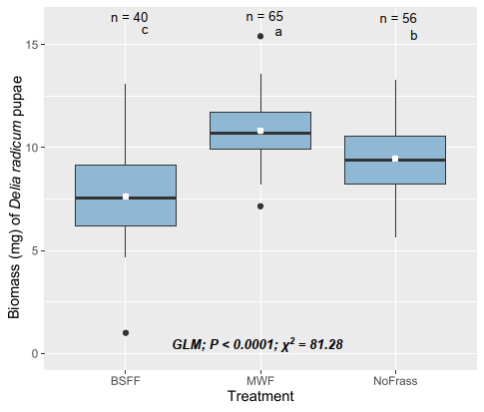

**Figure 4.** Biomass (mg) of *Delia radicum* pupae retrieved after a 21-day root infestation of *B. rapa* grown in unamended soil (NoFrass; control) or soil amended with raw BSF frass (BSFF) or raw yellow mealworm frass (MWF) recorded in Trial 1. The box represents the interquartile range (IQR), with the bottom and top edges corresponding to the first quartile (Q1, 25%) and third quartile (Q3, 75%), respectively. The line within the box represents the median, while the whiskers extend to 1.5 times the IQR, encompassing the minimum (Q1-1.5IQR) and maximum (Q3+1.5IQR) values. The dots beyond the whiskers represent outliers. The white square on each box represents the mean pupal biomass. Data were analysed with a generalised linear model (GLM). n is the number of pupae sampled per treatment. Boxes with different letters are significantly different (Tukey's post-hoc test, *p* < 0.05).

**Effect of raw frass on the emergence of *Delia radicum* adult flies**

The proportion of adult *D. radicum* flies that emerged from pupae was significantly affected by soil treatment (*χ2* = 6.06, df *=* 2*, p* = 0.0484; Figure S7A). The application of BSFF resulted in a significantly lower proportion of flies that emerged than application of MWF, but the effect was not significantly different from the NoFrass treatment (Figure S7A). The proportion of flies that emerged from plants exposed to MWF was similar to that from plants in the NoFrass group (Figure S7A). Although a similar pattern of emergence was recorded when this experiment was repeated under similar conditions, the proportion of flies that emerged did not differ significantly among soil treatments (*χ2* = 0.24, df *=* 2*, p* = 0.8896; Figure S7B). The time it took adult flies to eclose did not differ significantly among soil treatments (*χ2* = 0.92, df *=* 2*, p* = 0.6314; Figure S7C), and similar results were recorded when the experiment was repeated under similar conditions (*χ2* = 0.11, df *=* 2*, p* = 0.9468; Figure S7D).

**Effect of raw frass on feeding damage by *Plutella xylostella* larvae on *Brassica rapa* plants**

Soil amendment with raw frass did not affect larval feeding damage by *P. xylostella* caterpillars on the leaves of *B. rapa* plants in either of the two trials (Trial 1: *χ2* = 2.46, df = 2, *p* = 0.2931; Trial 2: *χ2* = 5.40, df = 2, *p* = 0.0672; Figure S8).

**Effect of raw frass on the survival of *Plutella xylostella* larvae on *Brassica rapa* plants**

The number of *P. xylostella* larvae that survived on *B. rapa* plants differed significantly among treatments (*χ2* = 129.23 df = 2, *p* < 0.0001; Figure 5). Amending soil with BSFF resulted in the lowest mean larval survival whereas MWF resulted in the highest mean larval survival (pupae retrieved) (Figure 5). A marginally different mean larval survival was recorded when this experiment was repeated under similar conditions (*χ2* = 5.84, df = 2, *p* < 0.0540; Figure S9).

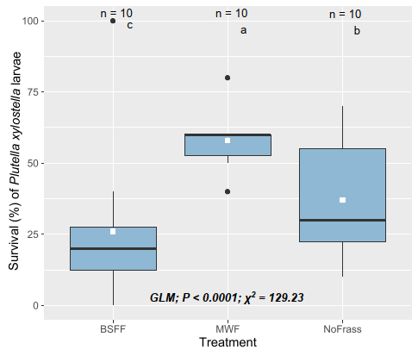

**Figure 5.** Survival of *Plutella xylostella* larvae on *B. rapa* grown in unamended soil (NoFrass; control) or soil amended with raw BSF frass (BSFF) or raw yellow mealworm frass (MWF) recorded in Trial 1. The box represents the interquartile range (IQR), with the bottom and top edges corresponding to the first quartile (Q1, 25%) and third quartile (Q3, 75%), respectively. The line within the box represents the median, while the whiskers extend to 1.5 times the IQR, encompassing the minimum (Q1-1.5IQR) and maximum (Q3+1.5IQR) values. The dots beyond the whiskers represent outliers. The white square on each box represents the mean larval survival per plant. Data were analysed by generalized linear models (GLM). n is the number of replicate plants that had each been infested with 10 larvae. Boxes with different letters are significantly different (Tukey’s post-hoc test, *p* < 0.05).

**Effects of incubated and composted frass on the growth of *Brassica rapa* plants**

Black soldier fly frass or MWF that had been incubated in the soil for 16 days, had no significant effect on the growth of *B. rapa* plants from germination to 28 days, but affected growth by day 35 (14 days: *χ2* = 1.22, df = 2, *p* = 0.5438; 21 days: *χ2* = 4.65, df = 2, *p* = 0.0977; 28 days: *χ2* = 3.40, df = 2, *p* = 0.1656; 35 days: *χ2* = 13.48, df = 2, *p* = 0.0012; Figure 6). Compared to the control (NoFrass) and BSFF, incubating MWF in the soil resulted in the highest mean leaf area by day 35 (Figure 6). Plants exposed to incubated BSFF had a similar leaf area as plants exposed to the NoFrass control.

When BSFF or MWF was composted before being added to the soil this affected leaf area at days 14 and 35 (14 days: *χ2* = 6.99, df = 2, *p* = 0.0303; 35 days: *χ2* = 8.86, df = 2, *p* = 0.0119; Figure 7), but not at days 21 and 28 (21 days: *χ2* = 2.23, df = 2, *p* = 0.3279; 28 days: *χ2* = 3.23, df = 2, *p* = 0.1993; Figure 7). Amending the soil with composted BSFF resulted in the lowest leaf area, which was significantly different from plants grown in soil amended with composted MWF and NoFrass at day 35 (Figure 7).

The number of leaves per *B. rapa* plant was not affected by incubated BSFF or MWF at any of the time points (14 days: *χ2* = 2.0, df = 2, *p* = 0.3679; 21 days: *χ2* = 3.42, df = 2, *p* = 0.1808; 28 days: *χ2* = 0.60, df = 2, *p* = 0.7419; 35 days: *χ2* = 1.77, df = 2, *p* = 0.4138; Figure S10). However, composted MWF significantly increased the number of leaves per plant at days 14 and 21 compared to the NoFrass (14 days: *χ2* = 11.69, df = 2, *p* = 0.0029; 21 days: *χ2* = 7.72, df = 2, *p* = 0.0211; Figure S11), but not at days 28 and 35 (28 days: *χ2* = 4.14, df = 2, *p* = 0.1260; 35 days: *χ2* = 3.64, df = 2, *p* = 0.1622; Figure S11).

The time until the start of flowering was not significantly affected by the incubation of frass in the soil when compared to the NoFrass control (*χ2*= 0.13, df = 2, *p* = 0.9355; Figure S12A). Similarly, the time until flowering of *B. rapa* plants was not significantly affected by adding either composted BSFF or MWF to the soil (*χ2*= 0.26, df = 2, *p* = 0.8782; Figure S12B).

**Figure 6**. Leaf area (cm2) of *B. rapa* plants grown in unamended soil (NoFrass; control) or soil amended with BSF frass (BSFF) or yellow mealworm frass (MWF) after incubating. Incubation involved frass mixed with soil in 0.5 L plastic pots and moistened, and seeds were only sown after sixteen days under greenhouse conditions. The box represents the interquartile range (IQR), with the bottom and top edges corresponding to the first quartile (Q1, 25%) and third quartile (Q3, 75%), respectively. The line within the box represents the median, while the whiskers extend to 1.5 times the IQR, encompassing the minimum (Q1-1.5IQR) and maximum (Q3+1.5IQR) values. The hollow dots beyond the whiskers represent outliers. The white square on each box represents the mean leaf area per plant. Data were analysed with a generalised linear model (GLM). n is the number of replicate plants for leaf area measurements. Boxes with different letters are significantly different (Tukey's post hoc test, *p* < 0.05).

**Figure 7.** Leaf area (cm2) of *B. rapa* plants grown in unamended soil (NoFrass; control) or soil amended with BSF frass (BSFF) or yellow mealworm frass (MWF) after composting. Frass samples were composted for 38 days in plastic boxes and air-dried for 18 days. The resulting compost was pulverized and added to the soil. The box represents the interquartile range (IQR), with the bottom and top edges corresponding to the first quartile (Q1, 25%) and third quartile (Q3, 75%), respectively. The line within the box represents the median, while the whiskers extend to 1.5 times the IQR, encompassing the minimum (Q1-1.5IQR) and maximum (Q3+1.5IQR) values. The hollow dots beyond the whiskers represent outliers. The white square on each box represents the mean leaf area per plant. Data were analysed with a generalised linear model (GLM). n is the number of replicate plants for leaf area measurements. Boxes with different letters are significantly different (Fisher's Least Significant Difference post hoc test, *p* < 0.05).

**Discussion**

This study investigated the effect of soil amendment with raw, incubated, and composted frass of black soldier fly (BSFF) and yellow mealworm (MWF) on the growth of *B. rapa* plants. In addition, feeding damage inflicted by diamondback moth (*P. xylostella*) larvae, their survival and development and survival, growth and adult eclosion of the cabbage root fly (*D. radicum*) were quantified. Our results show that while both raw BSFF and MWF frass initially resulted in smaller leaf area and fewer leaves, the negative effect of raw MWF disappeared over time, whereas raw BSFF consistently resulted in a smaller leaf area and fewer leaves compared to both MWF and the NoFrass control. Raw BSFF resulted in longer time until flowering compared to MWF and the NoFrass control. Soil amendment with BSFF resulted in a significantly lower survival and biomass of *D. radicum* larvae and pupae respectively, while amendment with MWF frass resulted in a significantly higher *D. radicum* larval survival and biomass than on NoFrass control plants. Interestingly, soil amendment with BSFF resulted in a lower survival of *P. xylostella* larvae compared to the control and MWF. Larval feeding damage on the leaves of *B. rapa* was not significantly affected by frass treatments. Interestingly, when frass was incubated in the soil or composted before being added to the soil, it promoted the growth of *B. rapa*. Notably, the growth inhibition that was previously observed for raw BSFF and MWF had been eliminated by pretreating the frass.

The plant growth inhibition by raw frass use in our study is consistent with previous studies. For example, maize plant growth trials showed that soil amendment with BSFF resulted in stunted growth, fewer plant leaves, smaller leaf area, and lower N use efficiencies (Alattar et al., 2016; Gärttling et al., 2020). Recently, research on *B. oleracea* grown in soil amended with BSFF revealed a decrease in dry shoot biomass compared to a synthetic fertiliser (Wantulla et al., 2022). The effects of frass vary with plant species, insect species, and with time. The application of MWF did not increase biomass and nutrient uptake in barley plants. However, when frass was applied in combination with a synthetic N-P-K fertiliser, both biomass and nutrient uptake increased (Houben et al., 2020). Moreover, combining BSFF with synthetic fertilisers improved rice plant growth (Reswita et al., 2022; Zim et al., 2022). Lettuce plants grew better in soil that had been amended with BSFF than in soil that had been fertilised with urea or left unamended (Dzepe et al., 2022). Compared to unamended sandy soil, zucchini plants grown in BSFF- and MWF-treated soil were considerably taller, had a bigger leaf area, and bigger dry leaf weights (Zim et al., 2022).

A probable explanation for the negative effect of raw frass on plant growth in the current study is that the frass used might have contained compounds that interfere with plant growth. Frass quality depends on the larval substrate as well as postharvest processing. Soil amendment with frass in this study might have altered the physical properties of the soil and obstructed root growth. Excess frass in the soil can lead to soil compaction or waterlogging, limiting the availability of oxygen and essential nutrients to plant roots (Liu et al., 2019). Alternatively, frass salinity may have caused inhibitory effects on plant growth. For example, high salt content can disrupt the balance of ions and nutrients in the soil, impairing plant growth (Zhang et al., 2012). It should be noted that the quality of the raw frass used in this study may have been impacted by the extended heat treatment (24 h at 60 °C) compared to the shorter duration of 1 h at 70 °C required by the EU Commission regulation EU 2021/1925, and confirmed by Van Looveren et al.'s (2021) study, which assessed the effects of this heat treatment on BSFF and found that a heat treatment at 70 °C for 1 h slightly reduced total microbial counts without affecting bacterial endospores. However, it successfully eliminated detectable amounts of foodborne pathogens (*Salmonella*, *Clostridium perfringens*, and Enterobacteriaceae) when introduced to the frass. Hence, this heat treatment appears suitable for ensuring the microbiological safety of insect frass as a soil amendment (Van Looveren et al., 2021). The application of raw BSFF resulted in a longer time until flowering compared to MWF and the NoFrass control. However, when the experiment was repeated under similar conditions, no significant effect of soil treatment on time until flowering was observed. Overall, these findings suggest that the use of raw BSFF or raw MWF as soil amendments may have negative effects on the growth and flowering of *B. rapa* plants, particularly in terms of leaf production. However, the effect on time until flowering seems to be more variable. The disparities between the effects of raw frass in the current study and the positive results reported in other previous studies illustrate the difficulty in generalising the effect of frass as an organic fertiliser on plant growth performance.

Pests of cruciferous plants, especially brassicas, include *D. radicum* and *P. xylostella*. *Delia radicum* larvae feed on plant roots, but *P. xylostella* larvae feed on the leaves, resulting in severe reductions in plant growth and yield (Ahuja et al., 2010). In our study, amending soil with raw BSFF resulted in a significant decrease in the survival of *D. radicum* larvae and *P. xylostella* larvae. Similarly, soil amendment with raw BSFF resulted in the lowest *D. radicum* pupal biomass, while MWF resulted in the highest pupal biomass. These findings suggest that the frass application negatively affected *D. radicum* larvae in the soil, and *P. xylostella* larvae feeding on the leaves of *B. rapa*. However, it is important to note that the effectiveness of BSFF to control pests may vary depending on the specific properties of both the frass and the soil type used (Wantulla et al., 2023). While the activation of plant defensive responses following frass treatments has been attributed to the presence of eliciting molecules or microorganisms (Poveda, 2021), the particular mechanisms responsible for the lower herbivore performance in soil amendments with raw BSFF in the current study remain to be elucidated to assess their potential to contribute to pest management in agriculture.

Our findings indicate that soil amendment with raw frass did not have a significant impact on the damage caused by larvae of *P. xylostella* feeding on the leaves of *B. rapa*. It remains to be investigated what the effects are on natural enemies of *P. xylostella*.

Intriguingly, amending soil with raw MWF resulted in higher herbivore performance than raw BSFF amendment. We hypothesised that the addition of frass to the soil would reduce herbivore performance by inducing plant defenses against herbivorous insect pests (Barragán-Fonseca et al., 2022; Ray et al., 2015). However, it appears that the addition of MWF to the soil favoured the survival and biomass accumulation in root-feeding *D. radicum* larvae and provided better and readily available plant nutrition forleaf-feeding *P. xylostella* larvae. For instance, a pot experiment indicated a high mineralisation of MWF particularly at higher rates of application (Houben et al., 2021). Moreover, the addition of MWF may have altered the soil microbial community, potentially favouring the growth of microorganisms that are beneficial to the cabbage root fly larvae (Wantulla et al., 2023). It is also possible that the MWF used in our study had a different chemical and/or microbial composition than other sources of insect frass that have been shown to induce plant defenses (Poveda et al., 2019).

Different insect species produce different types and amounts of defensive compounds, so the composition of frass can vary depending on the insect species used (Ray et al., 2016). A greenhouse experiment to measure frass-induced plant defences of maize, rice, cabbage and tomato plants showed that caterpillar-frass-induced plant defences are specific to each host-herbivore system and can induce herbivore or pathogen defence responses in the host plant depending on the composition of the frass deposited, the plant organ where it is deposited, and the insect species (Poveda, 2021; Ray et al., 2016). However, herbivore performance on maize plants was enhanced due to cues that suppressed herbivore defenses (Ray et al., 2015). Overall, our findings indicate that soil amendment with raw BSFF has a detrimental effect on herbivore performance, while the use of raw MWF may have a protective effect. The mechanisms that underpin these results and the factors that may have promoted herbivore performance soil amended with raw MWF need further study. The results of our study align with certain prior reports, while contradicting others, as anticipated because of the differences in the frass origins and quality employed in this study and those reported previously. This discrepancy highlights the need for additional research to broaden our understanding of the potential of frass application for soil enhancement and plant growth promotion.

A fascinating finding from the present study is that the process of incubating and composting raw frass alleviated the inhibition of plant growth. Incubating MWF in the soil before sowing *B. rapa* seeds resulted in a larger plant leaf area compared to the NoFrass control. Furthermore, composted MWF significantly increased the number of leaves per plant. Frass contains macronutrients like N, P, K, micronutrients, and beneficial microbes. Adding frass to the soil makes these nutrients readily available to the plants, which in turn may improve plant growth (Gärttling & Schulz, 2022; Gebremikael et al., 2022; Houben et al., 2020; Poveda, 2021; Poveda et al., 2019). The use of organic fertilisers, including animal manure and compost, has been associated with enhanced soil fertility and plant growth (Bashir et al., 2021; Rayne & Aula, 2020), aligning with our findings. Interestingly, the incubation of frass in the soil did not significantly affect the time until flowering of *B. rapa*. This suggests that the effects of frass on plant growth and development may be more pronounced during the vegetative stage of growth than during the reproductive stage.

A limitation of the current study is that while we tested the effects of raw frass on both plant growth and herbivore performance, we tested the effects of incubated and composted frass only on plant growth. This means that we do not have a complete understanding of the effects of these different types of frass on herbivore performance. In future studies, it will be important to include measurements of herbivore performance when testing the effects of different types of frass on plant growth.

**Conclusions**

This study has shown that the use of BSFF and MWF have potential as alternative sources of organic fertilisers for sustainable agriculture. However, the use of raw BSFF may also have implications for insect herbivore control, as it decreases the performance of *D. radicum* and *P. xylostella* larvae. In contrast, the use of raw MWF increases the survival of these pests. Additionally, the effect of incubating and composting frass on plant growth performance highlights the importance of proper handling and treatment of frass to maximize its potential benefits. This study indicates that it may be more effective to incubate frass in the soil before sowing seeds. These findings suggest that an integrated approach, combining the use of frass as a sustainable fertiliser with pest management strategies, may lead to sustainable agricultural practices.

Future studies should compare the effects of raw frass, incubated and composted frass on insect herbivores, and the mechanisms of action to understand their potential for sustainable herbivore control.

**Acknowledgements**

This work was funded by Wageningen University & Research through the Africa Talent Programme (ATP). We are grateful to Azkia Nurfikari for oven-drying frass samples and to Daan Mertens and Thibault Costaz for their helpful advice on the statistical analysis of data in this study.

**Declaration of conflict of interest**

The authors declare that they do not have a conflict of interest.

**Supplementary material**

**Effects of frass from larvae of black soldier fly (*Hermetia illucens*) and yellow mealworm (*Tenebrio molitor*) on growth and insect resistance in field mustard (*Brassica rapa*): differences between insect species and frass treatments**

Shaphan Y. Chia, Joop J.A. van Loonand Marcel Dicke

Laboratory of Entomology, Wageningen University & Research, P.O. Box 16, 6700 AA Wageningen, the Netherlands.

**Table S1.** Summary of *Brassica rapa* seed germination for the four trials.

|  |  |  |  |  |  |  |
| --- | --- | --- | --- | --- | --- | --- |
| Trial | Seeds sown | Seeds germinated | * % Seed germination | Time (days) | Seed treatment | Germination method |
| 1 | 120 | 114 | 95.0 | 1-3 | stratified | germinated in unamended soil |
| 2 | 160 | 146 | 91.3 | 1-3 | stratified | germinated in unamended soil |
| 3 | 36 | 32 | 88.9 | 1-3 | stratified | Sown directly into amended soil |
| 4 | 51 | 45 | 88.2 | 1-3 | stratified | Sown directly into amended soil |

Seeds were stratified by maintaining them in moist filter papers in Petri dishes at 4 °C for 7 days. In trials 1 and 2, seedlings were transplanted into raw frass (no incubation or composting) soil after germination; Trial 3: frass incubated in the soil before seeds were sown; Trial 4: frass samples were composted, air-dried, and pulverised before being added to the soil. Data were analysed with a using the Chi-squared test. (*) There was no significant difference in the proportion of germinated seeds (p < 0.05).

**Figure S1**. Leaf area (cm2) of *B. rapa* plants grown in unamended soil (NoFrass; control) or soil amended with raw BSF frass (BSFF), or raw yellow mealworm frass (MWF) recorded in Trial 2. The box represents the interquartile range (IQR), with the bottom and top edges corresponding to the first quartile (Q1, 25%) and third quartile (Q3, 75%), respectively. The line within the box represents the median, while the whiskers extend to 1.5 times the IQR, encompassing the minimum (Q1-1.5IQR) and maximum (Q3+1.5IQR) values. The hollow dots beyond the whiskers represent outliers. The white square on each box represents the mean leaf area per plant. Data were analysed with a generalised linear model (GLM). n is the number of replicate plants for leaf area measurements. Boxes with different letters are significantly different (Tukey's post hoc test, *p* < 0.05).

**Figure S2**. Number of leaves of *B. rapa* plants grown in unamended soil (NoFrass; control) or soil amended with raw BSF frass (BSFF) or raw yellow mealworm frass (MWF) recorded in Trial 1. The box represents the interquartile range (IQR), with the bottom and top edges corresponding to the first quartile (Q1, 25%) and third quartile (Q3, 75%), respectively. The line within the box represents the median, while the whiskers extend to 1.5 times the IQR, encompassing the minimum (Q1-1.5IQR) and maximum (Q3+1.5IQR) values. The hollow dots beyond the whiskers represent outliers. The white square on each box represents the mean number of leaves per plant. Data were analysed by generalised linear models (GLM). n is the number of replicate plants for leaf counts. Boxes with different letters are significantly different (Tukey's post hoc test, *p* < 0.05).

**Figure S3**. Number of leaves of *B. rapa* plants grown in unamended soil (NoFrass; control) or soil amended with raw BSF frass (BSFF), or raw yellow mealworm frass (MWF) recorded in Trial 2. The box represents the interquartile range (IQR), with the bottom and top edges corresponding to the first quartile (Q1, 25%) and third quartile (Q3, 75%), respectively. The line within the box represents the median, while the whiskers extend to 1.5 times the IQR, encompassing the minimum (Q1-1.5IQR) and maximum (Q3+1.5IQR) values. The hollow dots beyond the whiskers represent outliers. The white square on each box represents the mean number of leaves per plant. Data were analysed by generalised linear models (GLM). n is the number of replicate plants for leaf counts. Boxes with different letters are significantly different (Tukey's post hoc test, *p* < 0.05).

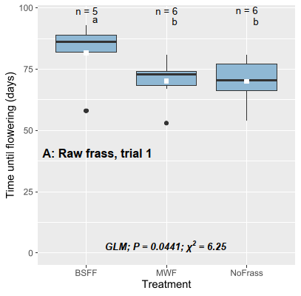 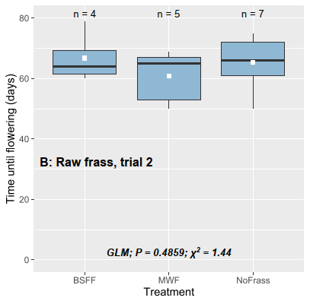

**Figure S4**. Time until flowering (days) of *B. rapa* grown in unamended soil (NoFrass; control) or soil amended with raw BSF frass (BSFF) or raw yellow mealworm frass (MWF) in two trials. A = trial 1 and B = trial 2. B is a repetition of A under similar conditions. The box represents the interquartile range (IQR), with the bottom and top edges corresponding to the first quartile (Q1, 25%) and third quartile (Q3, 75%), respectively. The line within the box represents the median, while the whiskers extend to 1.5 times the IQR, encompassing the minimum (Q1-1.5IQR) and maximum (Q3+1.5IQR) values. The dots beyond the whiskers represent outliers. The white square on each box represents the mean time until flowering per treatment. Data were analysed with a generalised linear model (GLM). n is the number of replicate plants on which time until flowering was recorded. Boxes with different letters are significantly different (Fisher's Least Significant Difference post hoc test, *p* < 0.05).

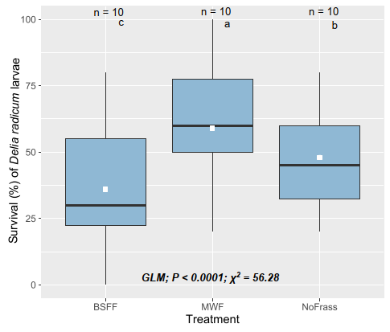

**Figure S5.** Survival of *Delia radicum* larvae on roots of *B. rapa* plants grown in unamended soil (NoFrass; control) or soil amended with raw BSF frass (BSFF) or raw yellow mealworm frass (MWF). The box represents the interquartile range (IQR), with the bottom and top edges corresponding to the first quartile (Q1, 25%) and third quartile (Q3, 75%), respectively. The line within the box represents the median, while the whiskers extend to 1.5 times the IQR, encompassing the minimum (Q1-1.5IQR) and maximum (Q3+1.5IQR) values. The white square on each box represents the mean larval survival. Data were analysed by generalised linear models (GLM). n is the number of replicate plants that had each been infested with 10 larvae. Boxes with different letters are significantly different (Tukey's post hoc test, *p* < 0.05).

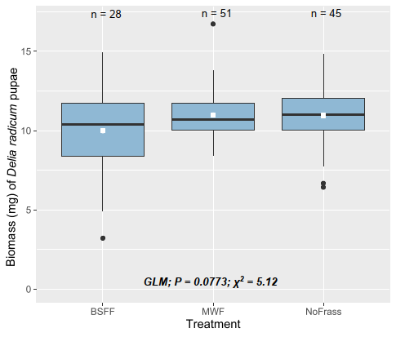

**Figure S6.** Biomass (mg) of *Delia radicum* pupae retrieved after a 21-day root infestation of *B. rapa* grown in unamended soil (NoFrass; control) or soil amended with raw BSF frass (BSFF) or raw yellow mealworm frass (MWF). The box represents the interquartile range (IQR), with the bottom and top edges corresponding to the first quartile (Q1, 25%) and third quartile (Q3, 75%), respectively. The line within the box represents the median, while the whiskers extend to 1.5 times the IQR, encompassing the minimum (Q1-1.5IQR) and maximum (Q3+1.5IQR) values. The dots beyond whiskers represent outliers. The white square on each box represents the mean pupal weight. Data were analysed with generalised linear models (GLM). n is the number of pupae weighed per treatment.

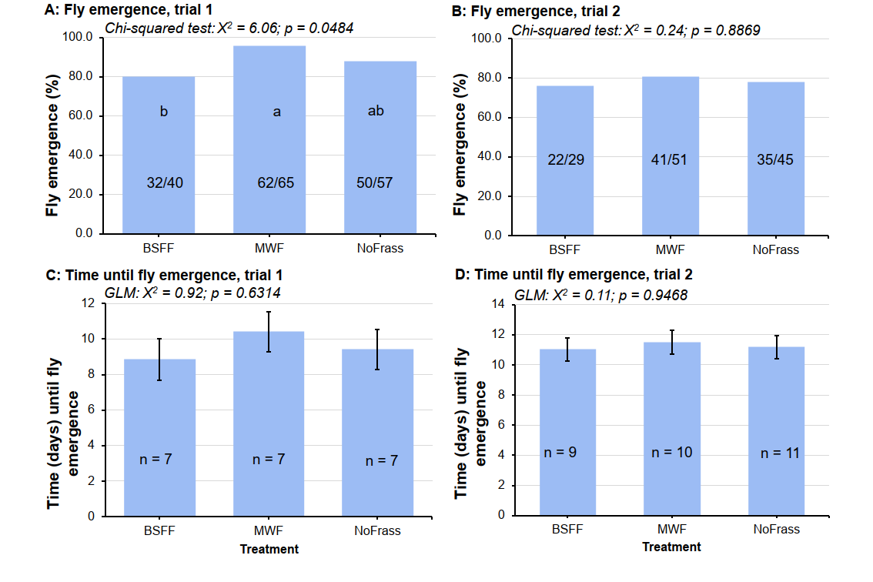

**Figure S7.** Emergence of *Delia radicum* adult flies after pupae were retrieved from the roots of *B. rapa* grown in unamended soil (NoFrass; control) or soil amended with raw BSF frass (BSFF) or raw yellow mealworm frass (MWF). A = proportion (%) of flies that emerged during the first trial (trial 1), B = proportion (%) of flies that emerged during the second trial (trial 2), C = time (mean ± S.E) until fly emergence during trial 1, and D = time (mean ± S.E) until fly emergence during trial 2. Data on the proportion of flies that emerged were analysed with the chi-squared test equality of proportions. The fractions (32/40, 62/65, 50/57, 22/29, 41/51 and 35/45) on the graph show the proportion of flies that emerged (numerator) out of the number of pupae (denominator). Data on time until fly emergence were analysed with a generalised linear model (GLM). n is the number of recorded instances of fly emergence. Error bars represent standard errors of the average time until emergence. Bars with different letters are significantly different following the Marascuilo procedure as a post hoc test (the absolute pairwise difference between proportions is statistically significant if its value exceeds the critical range value). Graphs without error bars represent single measurements (proportions).

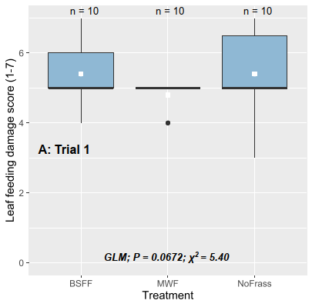 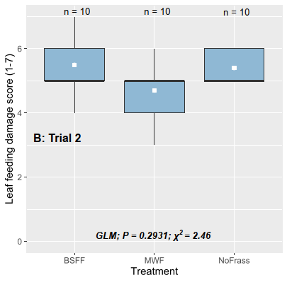

**Figure S8.** Feeding damage (scores) by larvae of *Plutella xylostella* on *B. rapa* grown in unamended soil (NoFrass; control) or soil amended with raw BSF frass (BSFF) or raw yellow mealworm frass (MWF) in two trials. A = trial 1 and B = trial 2. B is a repetition of A under similar conditions. The box represents the interquartile range (IQR), with the bottom and top edges corresponding to the first quartile (Q1, 25%) and third quartile (Q3, 75%), respectively. The line within the box represents the median, while the whiskers extend to 1.5 times the IQR, encompassing the minimum (Q1-1.5IQR) and maximum (Q3+1.5IQR) values. The dot beyond whiskers represents an outlier. The white square on each box represents the mean feeding damage. Data were analysed with a generalised linear model (GLM). n is the number of replicate plants for leaf damage assessment.

**Figure S9.** Survival (%) of *Plutella xylostella* larvae on *B. rapa* grown in unamended soil (NoFrass; control) or soil amended with raw BSF frass (BSFF) or raw yellow mealworm frass (MWF). The box represents the interquartile range (IQR), with the bottom and top edges corresponding to the first quartile (Q1, 25%) and third quartile (Q3, 75%), respectively. The line within the box represents the median, while the whiskers extend to 1.5 times the IQR, encompassing the minimum (Q1-1.5IQR) and maximum (Q3+1.5IQR) values. The dot beyond whisker represents an outlier. The white square on each box represents the mean larval survival per plant. Data were analysed with a generalised linear model (GLM). n is the number of replicate plants that were each infested with 10 larvae.

**Figure S10**. Number of leaves of *B. rapa* grown in unamended soil (NoFrass; control) or soil amended with BSF frass (BSFF) or yellow mealworm frass (MWF) after incubating. Incubation involved frass mixed with soil in 0.5 L plastic pots and moistened, and seeds were only sown after sixteen days under greenhouse conditions. The box represents the interquartile range (IQR), with the bottom and top edges corresponding to the first quartile (Q1, 25%) and third quartile (Q3, 75%), respectively. The line within the box represents the median, while the whiskers extend to 1.5 times the IQR, encompassing the minimum (Q1-1.5IQR) and maximum (Q3+1.5IQR) values. The hollow dots beyond whiskers represent outliers. The white square on each box represents the mean number of leaves. Data were analysed with a generalised linear model (GLM). n is the number of replicate plants for leaf counts.

**Figure S11**. Number of leaves of *B. rapa* grown in unamended soil (NoFrass; control) or soil amended with BSF frass (BSFF) or yellow mealworm frass (MWF) after composting. Frass samples were composted for 38 days in plastic boxes and air-dried. The resulting compost was pulverized and added to the soil. The box represents the interquartile range (IQR), with the bottom and top edges corresponding to the first quartile (Q1, 25%) and third quartile (Q3, 75%), respectively. The line within the box represents the median, while the whiskers extend to 1.5 times the IQR, encompassing the minimum (Q1-1.5IQR) and maximum (Q3+1.5IQR) values. The hollow dots beyond whiskers represent outliers. The white square on each box represents the mean number of leaves. Data were analysed with a generalised linear model (GLM). n is the number of replicate plants for leaf counts. Boxes with different letters are significantly different (Tukey's post hoc test, *p* < 0.05).

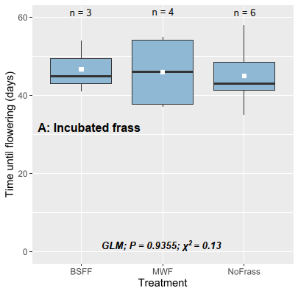 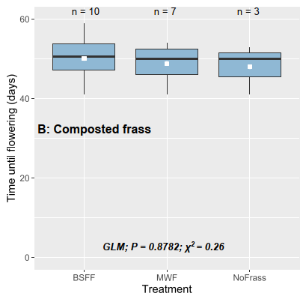

**Figure S12.** Time until flowering (days) of *B. rapa* grown soil (NoFrass; control) or soil amended with BSF frass (BSFF) or yellow mealworm frass (MWF). A = frass was incubated in the soil for 16 days before seeds were sown and, B = frass was composted for 38 days in plastic boxes and air-dried. The resulting compost was pulverized and added to the soil. The box represents the interquartile range (IQR), with the bottom and top edges corresponding to the first quartile (Q1, 25%) and third quartile (Q3, 75%), respectively. The line within the box represents the median, while the whiskers extend to 1.5 times the IQR, encompassing the minimum (Q1-1.5IQR) and maximum (Q3+1.5IQR) values. The white square on each box represents the mean flowering time. Data were analysed with a generalised linear model (GLM). n is the number of replicate plants observed for time until flowering.

**References**

Adedia D, Asem L, Appiah SK, Nanga S, Boateng Y, Duedu KO & Anani L (2020) Assessment of hypertension-induced deaths in Ghana: a nation-wide study from 2012 to 2016. Journal of Data Analysis and Information Processing 8: 158-170.

Ahuja I, Rohloff J & Bones AM (2010) Defence mechanisms of Brassicaceae: implications for plant-insect interactions and potential for integrated pest management. A review. Agronomy for Sustainable Development 30: 311-348.

Alattar MA, Alattar FN & Popa R (2016) Effects of microaerobic fermentation and black soldier fly larvae food scrap processing residues on the growth of corn plants (Zea mays). Plant Science Today 3: 57-62.

Barragán-Fonseca KY, Nurfikari A, van de Zande EM, Wantulla M, van Loon JJA, de Boer W & Dicke M (2022) Insect frass and exuviae to promote plant growth and health. Trends Plant Science 27: 646-654.

Barthod J, Rumpel C & Dignac M-F (2018) Composting with additives to improve organic amendments. A review. Agronomy for Sustainable Development 38: 17.

Bashir S, Bakhsh Gulshan A, Iqbal J, Husain A, Alwahibi MS, Alkahtani J, Dwiningsih Y, Bakhsh A, Ahmed N, Jamal Khan M, Ibrahim M & Diao Z-H (2021) Comparative role of animal manure and vegetable waste induced compost for polluted soil restoration and maize growth. Saudi Journal of Biological Sciences 28: 2534-2539.

Basri NEA, Azman NA, Ahmad IK, Suja F, Jalil NAA & Amrul NF (2022) Potential applications of frass derived from black soldier fly larvae treatment of food waste: A review. Foods 11: 2664.

Basu A, Prasad P, Das SN, Kalam S, Sayyed R, Reddy M & El Enshasy H (2021) Plant growth promoting rhizobacteria (PGPR) as green bioinoculants: recent developments, constraints, and prospects. Sustainability 13: 1140.

Berendsen RL, Pieterse CM & Bakker PA (2012) The rhizosphere microbiome and plant health. Trends Plant Science 17: 478-486.

Chia SY, Tanga CM, Osuga IM, Cheseto X, Ekesi S, Dicke M & van Loon JJA (2020) Nutritional composition of black soldier fly larvae feeding on agro‐industrial by‐products. Entomologia Experimentalis et Applicata 168: 472-481.

Chia SY, Tanga CM, van Loon JJA & Dicke M (2019) Insects for sustainable animal feed: inclusive business models involving smallholder farmers. Current Opinion in Environmental Sustainability 41: 23-30.

Choi S & Hassanzadeh N (2019) BSFL frass: A novel biofertilizer for improving plant health while minimizing environmental impact. Candian Science Fair Journal 2: 41-46.

Dzepe D, Mbenda TK, Ngassa G, Mube H, Chia SY, Aoudou Y & Djouaka R (2022) Application of black soldier fly frass, *Hermetia illucens* (Diptera: Stratiomyidae) as sustainable organic fertilizer for lettuce, *Lactuca sativa* production. Open Journal of Applied Sciences 12: 1632-1648.

Fox J, Weisberg S, Adler D, Bates D, Baud-Bovy G, Ellison S, Firth D, Friendly M, Gorjanc G & Graves S (2012) Package ‘car’. Vienna: R Foundation for Statistical Computing 16.

Gadhave KR, Finch P, Gibson TM & Gange AC (2016) Plant growth-promoting Bacillus suppress *Brevicoryne brassicae* field infestation and trigger density-dependent and density-independent natural enemy responses. Journal of Pest Science 89: 985-992.

Gärttling D, Kirchner SM & Schulz H (2020) Assessment of the N-and P-fertilization effect of black soldier fly (Diptera: Stratiomyidae) by-products on maize. Journal of Insect Science 20: 8.

Gärttling D & Schulz H (2022) Compilation of black soldier fly frass analyses. Journal of Soil Science and Plant Nutrition 22: 937-943.

Gebremikael MT, van Wickeren N, Salehi Hosseini P & De Neve S (2022) The impacts of black soldier fly frass on nitrogen availability, microbial activities, C sequestration, and plant growth. Frontiers in Sustainable Food Systems 6: 795950

Goldan E, Nedeff V, Barsan N, Culea M, Panainte-Lehadus M, Mosnegutu E, Tomozei C, Chitimus D & Irimia O (2023) Assessment of manure compost used as soil amendment.A review. Processes 11: 1167.

Houben D, Daoulas G & Dulaurent A-M (2021) Assessment of the short-term fertilizer potential of mealworm frass using a pot experiment. Frontiers in Sustainable Food Systems 5: 714596.

Houben D, Daoulas G, Faucon M-P & Dulaurent A-M (2020) Potential use of mealworm frass as a fertilizer: Impact on crop growth and soil properties. Scientific Reports 10: 4659.

Hu L, Robert CAM, Cadot S, Zhang X, Ye M, Li B, Manzo D, Chervet N, Steinger T, van der Heijden MGA, Schlaeppi K & Erb M (2018) Root exudate metabolites drive plant-soil feedbacks on growth and defense by shaping the rhizosphere microbiota. Nature Communications 9: 2738.

Klammsteiner T, Turan V, Fernández-Delgado Juárez M, Oberegger S & Insam H (2020) Suitability of black soldier fly frass as soil amendment and implication for organic waste hygienization. Agronomy 10: 1578.

Lenth R & Lenth MR (2018) Package ‘lsmeans’. The American Statistician 34: 216-221.

Lopes IG, Yong JW & Lalander C (2022) Frass derived from black soldier fly larvae treatment of biodegradable wastes. A critical review and future perspectives. Waste Management 142: 65-76.

Mahapatra S, Yadav R & Ramakrishna W (2022) *Bacillus subtilis* impact on plant growth, soil health and environment: Dr. Jekyll and Mr. Hyde. Journal of Applied Microbiology 132: 3543-3562.

Mariod AA (2020) Nutrient composition of mealworm (*Tenebrio molitor*). African edible insects as alternative source of food, oil, protein and bioactive components (ed. by AA Mariod) Springer Cham, Switzerland AG, pp. 275-280.

Nicolopoulou-Stamati P, Maipas S, Kotampasi C, Stamatis P & Hens L (2016) Chemical pesticides and human health: the urgent need for a new concept in agriculture. Frontiers in public health 4: 148.

Nurfikari A & de Boer W (2021) Chitin determination in residual streams derived from insect production by LC-ECD and LC-MS/MS methods. Frontiers in Sustainable Food Systems 5: 795694..

Pangesti N, Pineda A, Pieterse CM, Dicke M & Van Loon JJA (2013) Two-way plant mediated interactions between root-associated microbes and insects: from ecology to mechanisms. Frontiers in Plant Science 4: 414.

Pineda A, Zheng SJ, van Loon JJA, Pieterse CM & Dicke M (2010) Helping plants to deal with insects: the role of beneficial soil-borne microbes. Trends Plant Science 15: 507-514.

Poveda J (2021) Insect frass in the development of sustainable agriculture. A review. Agronomy for Sustainable Development 41: 5.

Poveda J, Jiménez-Gómez A, Saati-Santamaría Z, Usategui-Martín R, Rivas R & García-Fraile P (2019) Mealworm frass as a potential biofertilizer and abiotic stress tolerance-inductor in plants. Applied Soil Ecology 142: 110-122.

Ray S, Basu S, Rivera-Vega LJ, Acevedo FE, Louis J, Felton GW & Luthe DS (2016) Lessons from the far end: caterpillar frass-induced defenses in maize, rice, cabbage, and tomato. Journal of Chemical Ecology 42: 1130-1141.

Ray S, Gaffor I, Acevedo FE, Helms A, Chuang W-P, Tooker J, Felton GW & Luthe DS (2015) Maize plants recognize herbivore-associated cues from caterpillar frass. Journal of Chemical Ecology 41: 781-792.

Rayne N & Aula L (2020) Livestock manure and the impacts on soil health.A review. Soil Systems 4: 64.

Reswita R, Noli ZA & Rahayu R (2022) Effect of giving frass *Hermetia Illucens* L. on soil physical chemical properties, chlorophyll content and yield of upland rice (Oryza Sativa L.) on Ultisol Soil. Eduvest-Journal of Universal Studies 2: 335-346.

Robin AHK, Hossain MR, Park JI, Kim HR & Nou IS (2017) Glucosinolate profiles in cabbage genotypes influence the preferential feeding of diamondback moth (*Plutella xylostella*). Frontiers in Plant Science 8: 1244.

Salomone R, Saija G, Mondello G, Giannetto A, Fasulo S & Savastano D (2017) Environmental impact of food waste bioconversion by insects: application of life cycle assessment to process using *Hermetia illucens*. Journal of Cleaner Production 140: 890-905.

Schmitt E & de Vries W (2020) Potential benefits of using *Hermetia illucens* frass as a soil amendment on food production and for environmental impact reduction. Current Opinion in Green and Sustainable Chemistry 25: 100335.

Sharp RG (2013) A review of the applications of chitin and its derivatives in agriculture to modify plant-microbial interactions and improve crop yields. Agronomy 3: 757-793.

Tartaglia FdL, Righi EZ, Rocha Ld, Loose LH, Maldaner IC & Heldwein AB (2016) Non-destructive models for leaf area determination in canola. Revista Brasileira de Engenharia Agrícola e Ambiental 20: 551-556.

Toviho OA & Bársony P (2022) Nutrient composition and growth of yellow mealworm (*Tenebrio molitor*) at different ages and stages of the life cycle. Agriculture 12: 1924.

van Huis A (2013) Potential of Insects as Food and Feed in Assuring Food Security. Annual Review of Entomology 58: 563-583.

van Looveren N, Vandeweyer D & Van Campenhout L (2021) Impact of heat treatment on the microbiological quality of frass originating from black soldier fly larvae (*Hermetia illucens*). Insects 13: 22.

Wagh ST & Razvi NA (2016) Marascuilo method of multiple comparisons (an analytical study of caesarean section delivery). International Journal of Contemporary Medical Research 43: 1137-1140.

Wantulla M, Dicke M & van Loon JJA (2023). Effects of amending soil with black soldier fly frass on survival and growth of the cabbage root fly (*Delia radicum*) depend on soil type. Under review

Wantulla M, van Loon JJA & Dicke M (2023) Soil amendment with insect exuviae causes species-specific changes in the rhizosphere bacterial community of cabbage plants. Applied Soil Ecology 188: 104854.

Wantulla M, van Zadelhoff K, van Loon JJA & Dicke M (2022) The potential of soil amendment with insect exuviae and frass to control the cabbage root fly. Journal of Applied Entomology 147: 181-191.

Wei S-J, Shi B-C, Gong Y-J, Jin G-H, Chen X-X & Meng X-F (2013) Genetic structure and demographic history reveal migration of the diamondback moth *Plutella xylostella* (Lepidoptera: Plutellidae) from the Southern to Northern Regions of China. PLOS ONE 8: e59654.

Young-Mathews A (2012) Plant guide for field mustard (*Brassica rapa* var. *rapa*). USDA-Natural Resources Conservation Service, Corvallis Plant Materials Center, Corvallis, OR. https://plants.usda.gov/DocumentLibrary/plantguide/pdf/pg_brrar.pdf (Accessed 8 May 2023).

Zeileis A, Kleiber C & Jackman S (2008) Regression models for count data in R. Journal of Statistical Software 27: 1-25.

Zhang Q, Rue K & Wang S (2012) Salinity effect on seed germination and growth of two warm-season native grass species. HortScience 47: 527-530.

Zim J, Aitikkou A, EL Omari MH, EL Malahi S, Azim K, Hirich A, Nilahyane A & Oumouloud A (2022) A new organic amendment based on insect frass for zucchini (*Cucurbita pepo* L.) cultivation. Environmental Sciences Proceedings 16: 28.

Zulkifli NFNM, Seok-Kian AY, Seng LL, Mustafa S, Kim Y-S & Shapawi R (2022) Nutritional value of black soldier fly (*Hermetia illucens*) larvae processed by different methods. PLoS One 17: e0263924.